EXPT NO:6 | INTEGRATE DATA FROM VARIOUS SOURCES FOR COMPREHENSIVE ANALYSIS USING TABLEAU AND POWERBI
DATE: 24.07.2026

PRE-LAB QUESTIONS (PROVIDE BRIEF ANSWERS TO THE FOLLOWING QUESTIONS) :

- What is data integration in the context of Business Intelligence (BI)?
Data integration is the process of combining data from multiple sources into a single system. It provides a unified view of information for analysis. This improves data consistency and accuracy. It also supports better business decision-making.

- Explain the difference between a join and a data blend in Tableau.
A join combines tables from the same data source into one dataset before analysis. Data blending combines data from different sources while keeping them separate. Joins are performed before visualisation, whereas blending occurs during analysis. Both methods help analyse related data effectively.

- What are relationships and cardinality (e.g., one-to-many, many-to-many) in Power BI's data model?
Relationships connect tables using common fields in the data model. Cardinality defines how records are related, such as one-to-many or many-to-many. These relationships ensure data is linked correctly. This improves the accuracy of reports and analysis.

- Why is data quality (e.g., consistent naming conventions, data types) crucial when integrating data from different sources?
High-quality data ensures that information is accurate and consistent across different sources. It reduces errors caused by incorrect names or mismatched data types. This improves the reliability of reports and dashboards. It also supports better business decisions.

5. Name two common challenges encountered during data integration.
Common challenges include missing or duplicate data and differences in data formats. These issues can lead to incorrect analysis and reporting. Proper data cleaning and validation help overcome these problems. This ensures accurate and reliable business insights.

IN-LAB EXERCISE:
OBJECTIVE:
To connect to, combine, and model data from multiple disparate sources in Tableau and Power BI to create a unified, comprehensive dashboard for holistic analysis. PROCEDURE:
- Data Collection:
  - Import data from at least two different sources (e.g., a CSV file and an Excel file).
  - Dataset 1: Sales Data (CSV file) with fields like Order ID, Order Date, Region, Sales Amount.
  - Dataset 2: Regional Sales Targets (Excel file) with fields like Region, Sales Target, Target Year.
- Data Preparation and Transformation:
  - Clean both datasets: Check for inconsistencies in region names (e.g., "N. America" vs. "North America"). o Ensure data types are correct (e.g., Sales Amount is numeric, Order Date is a date).
  - Handle any missing values as appropriate.
- Data Integration and Modeling:
  - Tableau: Use the Data Source pane to establish a relationship or join between the Sales Data and Regional Targets tables using the common Region field.
  - Power BI: Use the Model view to create a relationship between the two tables, connecting them on the Region column. Define the cardinality (e.g., many-to-one).
- Create Calculated Fields for Comparison:
  - Develop new measures that leverage both datasets.
  - Examples: Target Achievement % = (SUM(Sales) / SUM(Sales Target)) * 100
  - Sales vs. Target Variance = SUM(Sales) - SUM(Sales Target)
- Design a Comprehensive Dashboard:
  - Create visuals that combine data from both sources to provide a single view of performance.
  - Add KPI cards for Total Sales and Overall Target Achievement %. o Use a gauge chart or bullet chart to show sales performance against targets for each region. o Create a combined bar chart showing Actual Sales vs. Target Sales by Region.
  - Use a map to visualize the Sales vs. Target Variance, highlighting underperforming or overperforming regions.
- Validate Data Integrity:
  - Verify that the joined/related data is accurate by cross-checking values. o Ensure filters on the dashboard correctly update visuals that use data from both sources.
- Publishing and Sharing:
  - Tableau: Publish the workbook to Tableau Public or Tableau Server.
  - Power BI: Publish the report to Power BI Service and share the link.
Experiment Datasets:
Dataset 1: Retail Sales Data (CSV) Fields Used:
- Order ID – Unique identifier for each order
- Order Date – Date of the sales transaction
- Region – Sales region
- Sales – Sales revenue from the order
Dataset 2: Regional Sales Targets (Excel) Fields Used:
- Region – Sales region (used as the key for joining/relationship)
- Sales Target – The sales goal for the region
- Target Year – The year for which the target is set

Power BI DASHBOARD:
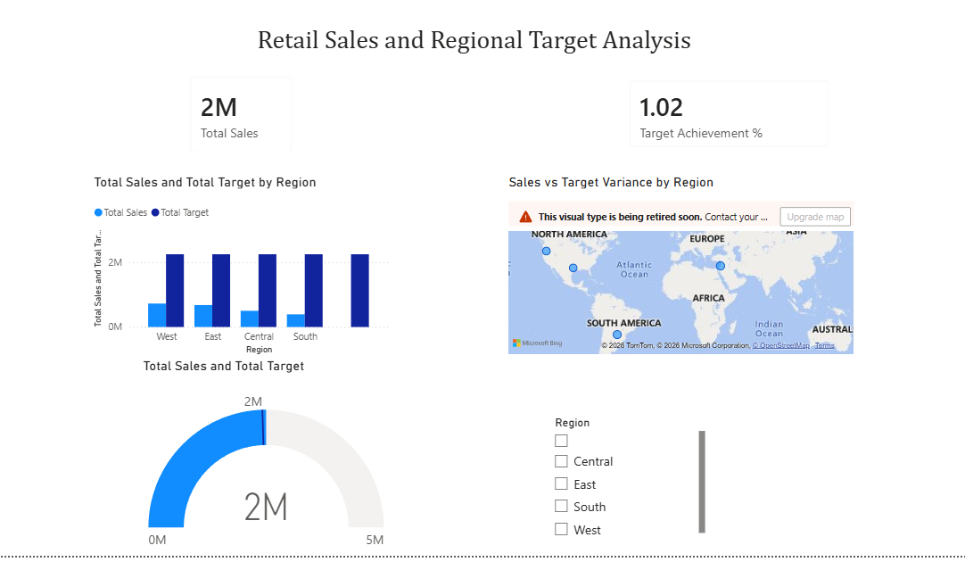
TABLEAU DASHBOARD:

POST-LAB QUESTIONS (PROVIDE BRIEF ANSWERS TO THE FOLLOWING QUESTIONS)
- How did integrating the sales targets data provide a more complete analytical picture than using the sales data alone?
Integrating sales targets with sales data allowed a comparison between actual performance and expected goals. It helped identify areas that exceeded or missed targets. This provided a clearer understanding of business performance. It also supported better planning and decision-making.
+
2. Describe the type of join or relationship you used to combine the two datasets and explain why it was the appropriate choice.
A one-to-many relationship was used to connect the datasets through a common field such as Region or Product ID. This ensured that each sales record matched the correct target. It maintained data accuracy during analysis. The relationship was suitable because one target related to multiple sales records.

3. What challenges, if any, did you face regarding data granularity or mismatched keys (e.g., different region names) between the two sources?
The main challenge was handling inconsistent region names and missing values between the datasets. Some records did not match because of differences in naming conventions. These issues were resolved by cleaning and standardising the data. This ensured successful integration and accurate analysis.

4. How can creating variance calculations (e.g., Sales vs. Target) help a business manager make better decisions?
Variance calculations show the difference between actual sales and target values. They help managers identify areas that are performing well or need improvement. This supports better resource allocation and performance monitoring. It also enables more informed business decisions.

5. What other data source (e.g., marketing campaign data, customer demographics) could you integrate to further enrich this analysis, and what new insights might it provide?
Customer demographics or marketing campaign data could be integrated with the sales data. This would help analyse customer behaviour and measure campaign effectiveness. It could reveal which customer groups generate the most sales. These insights would support more effective marketing and sales strategies.

RESULT:

The retail sales and regional targets datasets were successfully connected, cleaned, and integrated in both Tableau and Power BI. By creating relationships between the sources, a unified data model was built. The resulting comprehensive dashboard visualized sales performance against set targets, enabling variance analysis and providing deeper, context-rich insights into regional performance that were not possible with a single data source.

ASSESSMENT

Description |  | Max Marks | Marks Awarded
Pre Lab Exercise |  | 5
In Lab Exercise |  | 10
Post Lab Exercise |  | 5
Viva |  | 10
 | Total | 30
 | Faculty Signature

